Lista de Exercícios 1

Exercícios:

1 - Crie ao menos três ambientes conda

(base) gabrielmartins@hub-G3-3590:~$ conda create -n exemplo1
Collecting package metadata (current_repodata.json): done
Solving environment: done

## Package Plan ##
environment location: /home/gabrielmartins/miniconda3/envs/exemplo1
Proceed ([y]/n)? y
Preparing transaction: done
Verifying transaction: done
Executing transaction: done
#
# To activate this environment, use
#
# $ conda activate exemplo1
#
# To deactivate an active environment, use
#
# $ conda deactivate

(base) gabrielmartins@hub-G3-3590:~$ conda create -n exemplo2
Collecting package metadata (current_repodata.json): done
Solving environment: done

## Package Plan ##

environment location: /home/gabrielmartins/miniconda3/envs/exemplo2
Proceed ([y]/n)? y

Preparing transaction: done
Verifying transaction: done
Executing transaction: done
#
# To activate this environment, use
#
# $ conda activate exemplo2
#
# To deactivate an active environment, use
#
# $ conda deactivate

(base) gabrielmartins@hub-G3-3590:~$ conda create -n exemplo3
Collecting package metadata (current_repodata.json): done
Solving environment: done

## Package Plan ##

environment location: /home/gabrielmartins/miniconda3/envs/exemplo3
Proceed ([y]/n)? y

Preparing transaction: done
Verifying transaction: done
Executing transaction: done
#
# To activate this environment, use
#
# $ conda activate exemplo3
#
# To deactivate an active environment, use
#
# $ conda deactivate

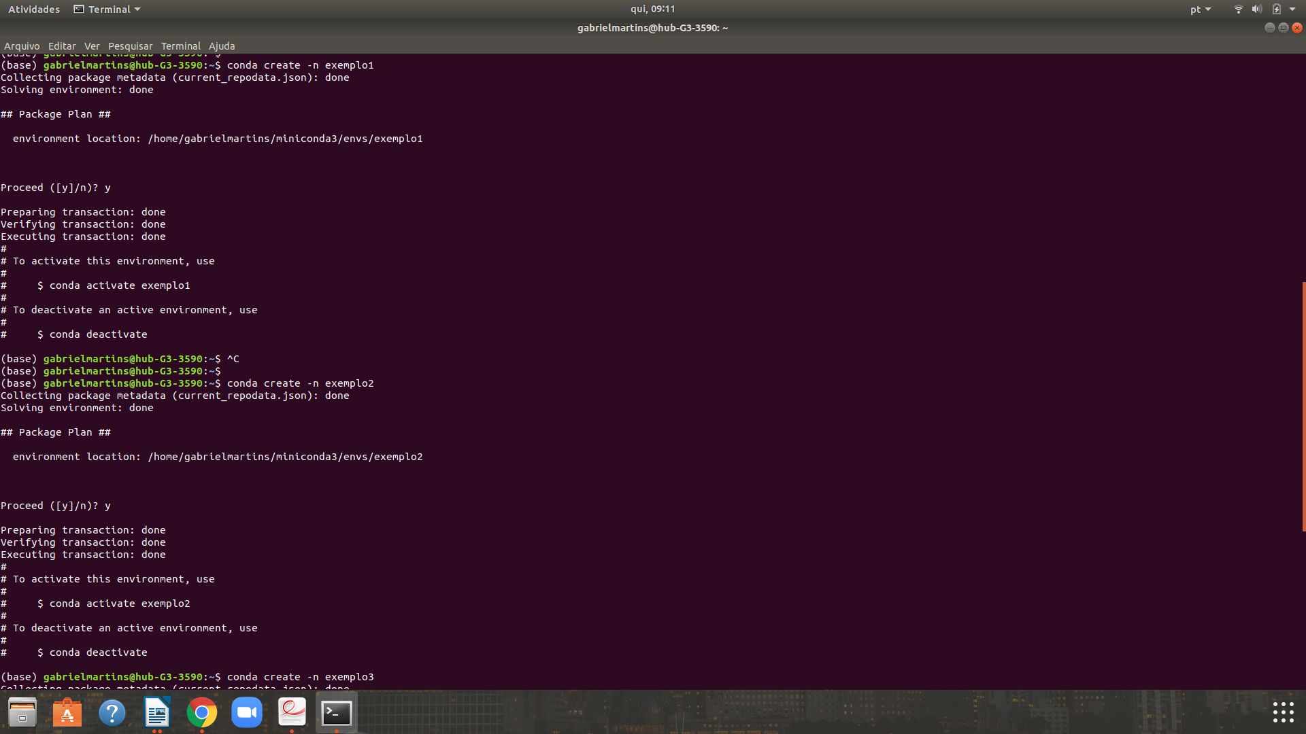
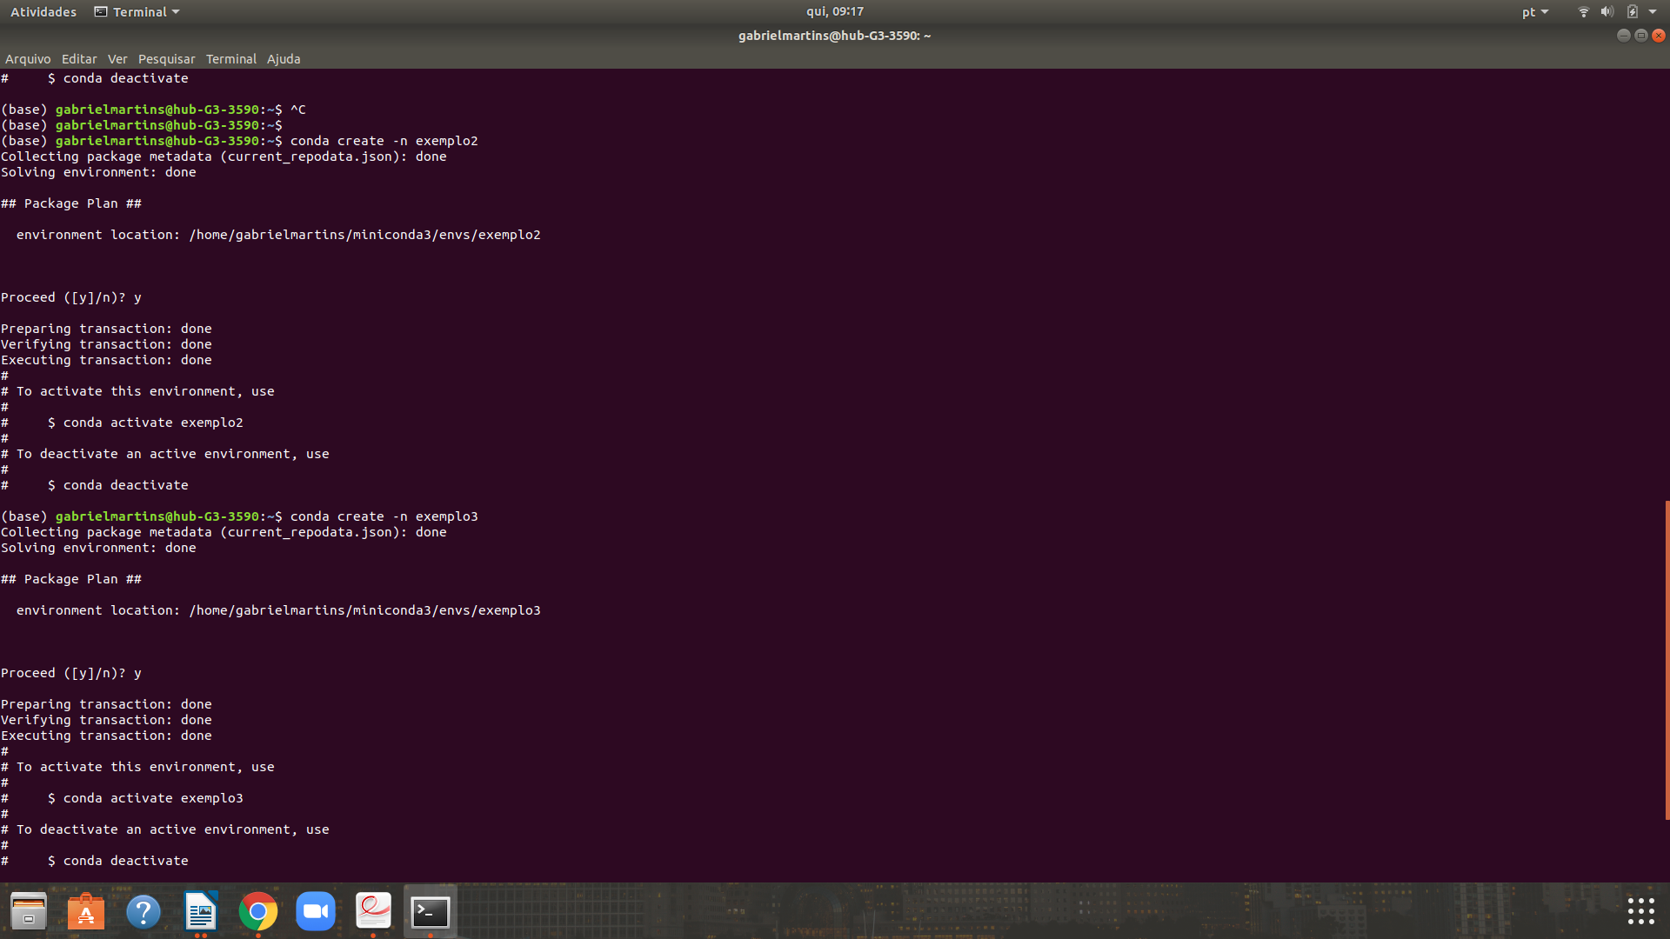

2- Liste os ambientes criados

(base) gabrielmartins@hub-G3-3590:~$ conda env list
# conda environments:
#
base * /home/gabrielmartins/miniconda3
exemplo1 /home/gabrielmartins/miniconda3/envs/exemplo1
exemplo2 /home/gabrielmartins/miniconda3/envs/exemplo2
exemplo3 /home/gabrielmartins/miniconda3/envs/exemplo3

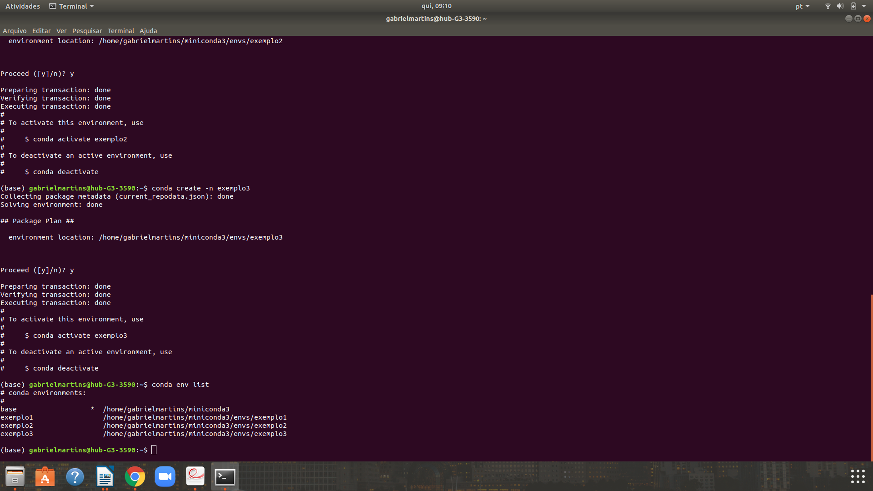
3- Instale ao menos dois pacotes em cada ambiente

// Instalação do pacote zope.event no ambiente (exemplo1)

(base) gabrielmartins@hub-G3-3590:~$ conda activate exemplo1
(exemplo1) gabrielmartins@hub-G3-3590:~$ conda install zope.event
Collecting package metadata (current_repodata.json): done
Solving environment: done

## Package Plan ##

environment location: /home/gabrielmartins/miniconda3/envs/exemplo1

added / updated specs:
- zope.event

The following packages will be downloaded:

package | build
---------------------------|-----------------
zope.event-4.4 | py37_0 10 KB
------------------------------------------------------------
Total: 10 KB

The following NEW packages will be INSTALLED:

_libgcc_mutex pkgs/main/linux-64::_libgcc_mutex-0.1-main
ca-certificates pkgs/main/linux-64::ca-certificates-2019.8.28-0
certifi pkgs/main/linux-64::certifi-2019.9.11-py37_0
libedit pkgs/main/linux-64::libedit-3.1.20181209-hc058e9b_0
libffi pkgs/main/linux-64::libffi-3.2.1-hd88cf55_4
libgcc-ng pkgs/main/linux-64::libgcc-ng-9.1.0-hdf63c60_0
libstdcxx-ng pkgs/main/linux-64::libstdcxx-ng-9.1.0-hdf63c60_0
ncurses pkgs/main/linux-64::ncurses-6.1-he6710b0_1
openssl pkgs/main/linux-64::openssl-1.1.1d-h7b6447c_2
pip pkgs/main/linux-64::pip-19.2.3-py37_0
python pkgs/main/linux-64::python-3.7.4-h265db76_1
readline pkgs/main/linux-64::readline-7.0-h7b6447c_5
setuptools pkgs/main/linux-64::setuptools-41.2.0-py37_0
sqlite pkgs/main/linux-64::sqlite-3.29.0-h7b6447c_0
tk pkgs/main/linux-64::tk-8.6.8-hbc83047_0
wheel pkgs/main/linux-64::wheel-0.33.6-py37_0
xz pkgs/main/linux-64::xz-5.2.4-h14c3975_4
zlib pkgs/main/linux-64::zlib-1.2.11-h7b6447c_3
zope.event pkgs/main/linux-64::zope.event-4.4-py37_0

Proceed ([y]/n)? y

Downloading and Extracting Packages
zope.event-4.4 | 10 KB | ##################################### | 100%
Preparing transaction: done
Verifying transaction: done
Executing transaction: done

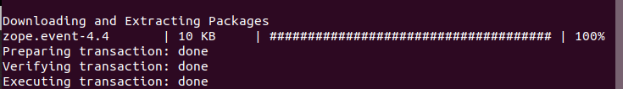
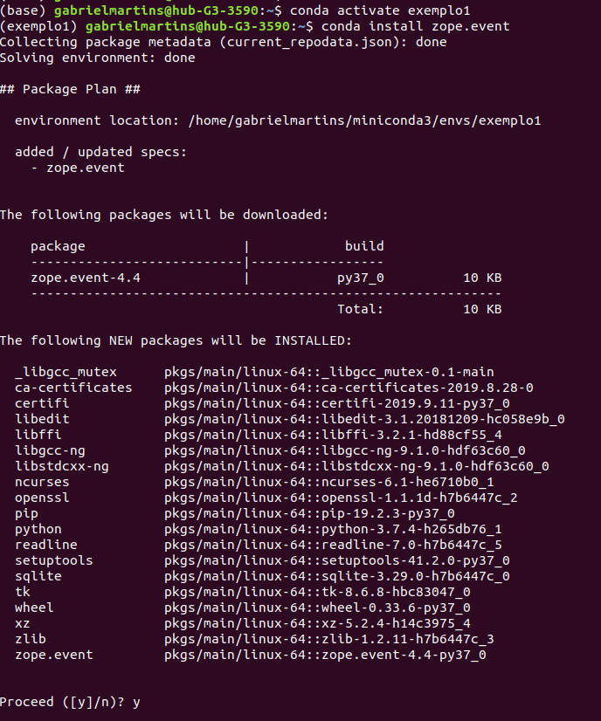

// Instalação pacote webob do ambiente (exemplo1)

(exemplo1) gabrielmartins@hub-G3-3590:~$ conda install webob
Collecting package metadata (current_repodata.json): done
Solving environment: done

## Package Plan ##

environment location: /home/gabrielmartins/miniconda3/envs/exemplo1

added / updated specs:
- webob

The following packages will be downloaded:

package | build
---------------------------|-----------------
webob-1.8.5 | py37_0 164 KB
------------------------------------------------------------
Total: 164 KB

The following NEW packages will be INSTALLED:

webob pkgs/main/linux-64::webob-1.8.5-py37_0

Proceed ([y]/n)? y

Downloading and Extracting Packages
webob-1.8.5 | 164 KB | ############################################################## | 100%
Preparing transaction: done
Verifying transaction: done
Executing transaction: done
(exemplo1) gabrielmartins@hub-G3-3590:~$

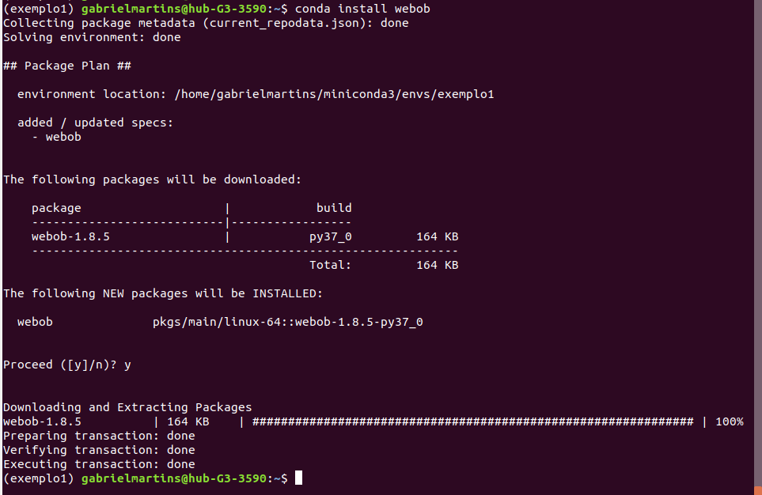
// Instalação dos pacotes wget e zipp

(base) gabrielmartins@hub-G3-3590:~$ conda activate exemplo2
(exemplo2) gabrielmartins@hub-G3-3590:~$ conda install wget
Collecting package metadata (current_repodata.json): done
Solving environment: done

## Package Plan ##

environment location: /home/gabrielmartins/miniconda3/envs/exemplo2

added / updated specs:
- wget

The following packages will be downloaded:

package | build
---------------------------|-----------------
wget-1.20.1 | h20c2e04_0 818 KB
------------------------------------------------------------
Total: 818 KB

The following NEW packages will be INSTALLED:

_libgcc_mutex pkgs/main/linux-64::_libgcc_mutex-0.1-main
ca-certificates pkgs/main/linux-64::ca-certificates-2019.8.28-0
libgcc-ng pkgs/main/linux-64::libgcc-ng-9.1.0-hdf63c60_0
openssl pkgs/main/linux-64::openssl-1.1.1d-h7b6447c_2
wget pkgs/main/linux-64::wget-1.20.1-h20c2e04_0
zlib pkgs/main/linux-64::zlib-1.2.11-h7b6447c_3

Proceed ([y]/n)? y

Downloading and Extracting Packages
wget-1.20.1 | 818 KB | ############################################################## | 100%
Preparing transaction: done
Verifying transaction: done
Executing transaction: done
(exemplo2) gabrielmartins@hub-G3-3590:~$ conda install zipp
Collecting package metadata (current_repodata.json): done
Solving environment: done

## Package Plan ##

environment location: /home/gabrielmartins/miniconda3/envs/exemplo2

added / updated specs:
- zipp

The following packages will be downloaded:

package | build
---------------------------|-----------------
more-itertools-7.2.0 | py37_0 100 KB
zipp-0.6.0 | py_0 9 KB
------------------------------------------------------------
Total: 109 KB

The following NEW packages will be INSTALLED:

certifi pkgs/main/linux-64::certifi-2019.9.11-py37_0
libedit pkgs/main/linux-64::libedit-3.1.20181209-hc058e9b_0
libffi pkgs/main/linux-64::libffi-3.2.1-hd88cf55_4
libstdcxx-ng pkgs/main/linux-64::libstdcxx-ng-9.1.0-hdf63c60_0
more-itertools pkgs/main/linux-64::more-itertools-7.2.0-py37_0
ncurses pkgs/main/linux-64::ncurses-6.1-he6710b0_1
pip pkgs/main/linux-64::pip-19.2.3-py37_0
python pkgs/main/linux-64::python-3.7.4-h265db76_1
readline pkgs/main/linux-64::readline-7.0-h7b6447c_5
setuptools pkgs/main/linux-64::setuptools-41.2.0-py37_0
sqlite pkgs/main/linux-64::sqlite-3.29.0-h7b6447c_0
tk pkgs/main/linux-64::tk-8.6.8-hbc83047_0
wheel pkgs/main/linux-64::wheel-0.33.6-py37_0
xz pkgs/main/linux-64::xz-5.2.4-h14c3975_4
zipp pkgs/main/noarch::zipp-0.6.0-py_0

Proceed ([y]/n)? y

Downloading and Extracting Packages
zipp-0.6.0 | 9 KB | ############################################################## | 100%
more-itertools-7.2.0 | 100 KB | ############################################################## | 100%
Preparing transaction: done
Verifying transaction: done
Executing transaction: done
(exemplo2) gabrielmartins@hub-G3-3590:~$

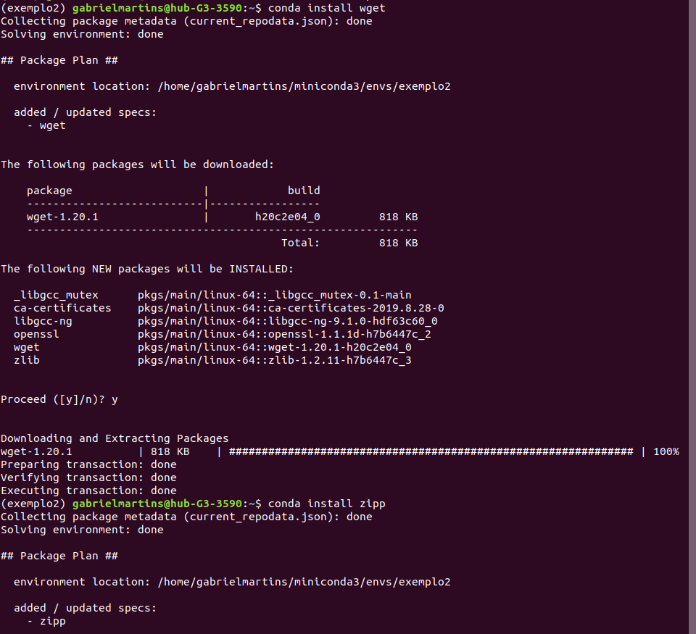
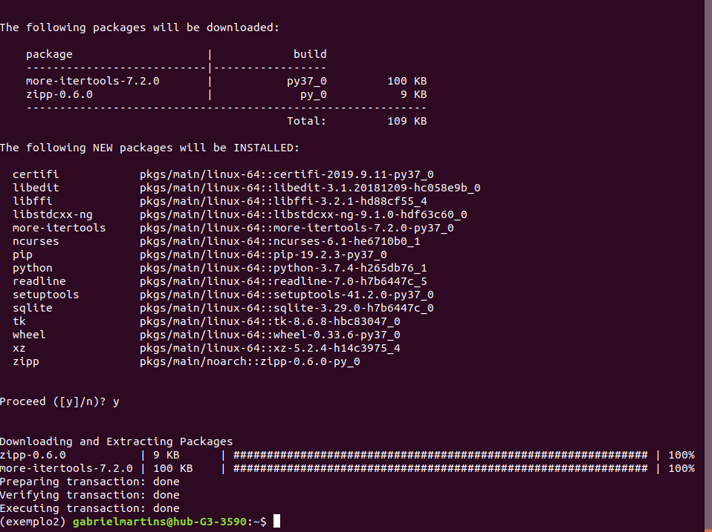

// Instalação dos pacotes xlwt e wcwidth no ambiente (exemplo3)

(base) gabrielmartins@hub-G3-3590:~$ conda activate exemplo3
(exemplo3) gabrielmartins@hub-G3-3590:~$ conda install xlwt
Collecting package metadata (current_repodata.json): done
Solving environment: done

## Package Plan ##

environment location: /home/gabrielmartins/miniconda3/envs/exemplo3

added / updated specs:
- xlwt

The following packages will be downloaded:

package | build
---------------------------|-----------------
xlwt-1.3.0 | py37_0 158 KB
------------------------------------------------------------
Total: 158 KB

The following NEW packages will be INSTALLED:

_libgcc_mutex pkgs/main/linux-64::_libgcc_mutex-0.1-main
ca-certificates pkgs/main/linux-64::ca-certificates-2019.8.28-0
certifi pkgs/main/linux-64::certifi-2019.9.11-py37_0
libedit pkgs/main/linux-64::libedit-3.1.20181209-hc058e9b_0
libffi pkgs/main/linux-64::libffi-3.2.1-hd88cf55_4
libgcc-ng pkgs/main/linux-64::libgcc-ng-9.1.0-hdf63c60_0
libstdcxx-ng pkgs/main/linux-64::libstdcxx-ng-9.1.0-hdf63c60_0
ncurses pkgs/main/linux-64::ncurses-6.1-he6710b0_1
openssl pkgs/main/linux-64::openssl-1.1.1d-h7b6447c_2
pip pkgs/main/linux-64::pip-19.2.3-py37_0
python pkgs/main/linux-64::python-3.7.4-h265db76_1
readline pkgs/main/linux-64::readline-7.0-h7b6447c_5
setuptools pkgs/main/linux-64::setuptools-41.2.0-py37_0
sqlite pkgs/main/linux-64::sqlite-3.29.0-h7b6447c_0
tk pkgs/main/linux-64::tk-8.6.8-hbc83047_0
wheel pkgs/main/linux-64::wheel-0.33.6-py37_0
xlwt pkgs/main/linux-64::xlwt-1.3.0-py37_0
xz pkgs/main/linux-64::xz-5.2.4-h14c3975_4
zlib pkgs/main/linux-64::zlib-1.2.11-h7b6447c_3

Proceed ([y]/n)? y

Downloading and Extracting Packages
xlwt-1.3.0 | 158 KB | ############################################################## | 100%
Preparing transaction: done
Verifying transaction: done
Executing transaction: done
(exemplo3) gabrielmartins@hub-G3-3590:~$ conda install wcwidth
Collecting package metadata (current_repodata.json): done
Solving environment: done

## Package Plan ##

environment location: /home/gabrielmartins/miniconda3/envs/exemplo3

added / updated specs:
- wcwidth

The following packages will be downloaded:

package | build
---------------------------|-----------------
wcwidth-0.1.7 | py37_0 22 KB
------------------------------------------------------------
Total: 22 KB

The following NEW packages will be INSTALLED:

wcwidth pkgs/main/linux-64::wcwidth-0.1.7-py37_0

Proceed ([y]/n)? y

Downloading and Extracting Packages
wcwidth-0.1.7 | 22 KB | ############################################################## | 100%
Preparing transaction: done
Verifying transaction: done
Executing transaction: done
(exemplo3) gabrielmartins@hub-G3-3590:~$

4- Liste os pacotes de cada ambiente
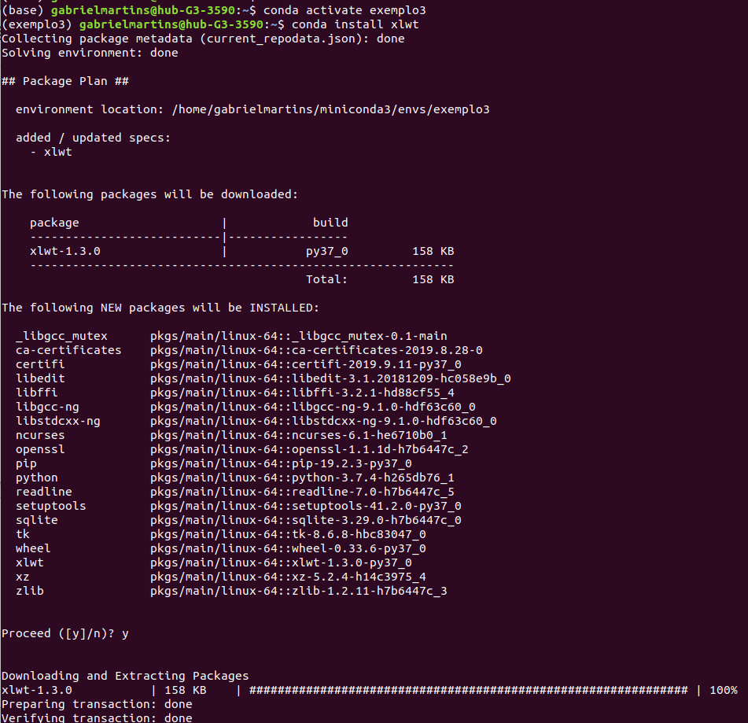
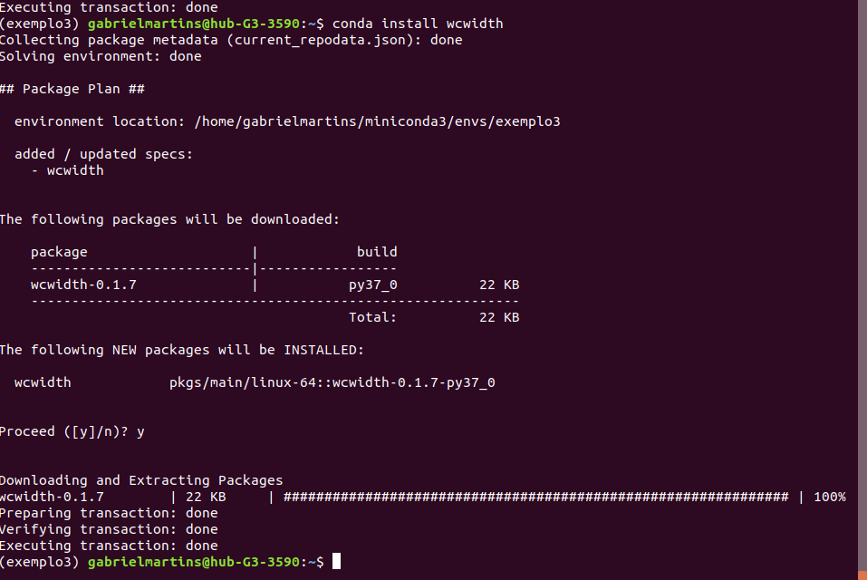

4- Liste os pacotes de cada ambiente

// lista dos pacotes instalados no ambiente (exemplo1)

(base) gabrielmartins@hub-G3-3590:~$ conda activate exemplo1
(exemplo1) gabrielmartins@hub-G3-3590:~$ conda list
# packages in environment at /home/gabrielmartins/miniconda3/envs/exemplo1:
#
# Name Version Build Channel
_libgcc_mutex 0.1 main
ca-certificates 2019.8.28 0
certifi 2019.9.11 py37_0
libedit 3.1.20181209 hc058e9b_0
libffi 3.2.1 hd88cf55_4
libgcc-ng 9.1.0 hdf63c60_0
libstdcxx-ng 9.1.0 hdf63c60_0
ncurses 6.1 he6710b0_1
openssl 1.1.1d h7b6447c_2
pip 19.2.3 py37_0
python 3.7.4 h265db76_1
readline 7.0 h7b6447c_5
setuptools 41.2.0 py37_0
sqlite 3.29.0 h7b6447c_0
tk 8.6.8 hbc83047_0
webob 1.8.5 py37_0
wheel 0.33.6 py37_0
xz 5.2.4 h14c3975_4
zlib 1.2.11 h7b6447c_3
zope.event 4.4 py37_0
(exemplo1) gabrielmartins@hub-G3-3590:~$
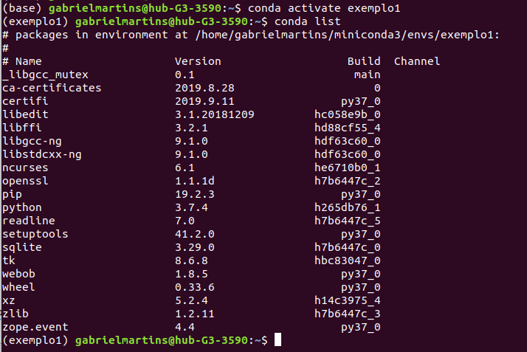
// lista de pacotes instalados no ambiente (exemplo2)

(base) gabrielmartins@hub-G3-3590:~$ conda activate exemplo2
(exemplo2) gabrielmartins@hub-G3-3590:~$ conda list
# packages in environment at /home/gabrielmartins/miniconda3/envs/exemplo2:
#
# Name Version Build Channel
_libgcc_mutex 0.1 main
ca-certificates 2019.8.28 0
certifi 2019.9.11 py37_0
libedit 3.1.20181209 hc058e9b_0
libffi 3.2.1 hd88cf55_4
libgcc-ng 9.1.0 hdf63c60_0
libstdcxx-ng 9.1.0 hdf63c60_0
more-itertools 7.2.0 py37_0
ncurses 6.1 he6710b0_1
openssl 1.1.1d h7b6447c_2
pip 19.2.3 py37_0
python 3.7.4 h265db76_1
readline 7.0 h7b6447c_5
setuptools 41.2.0 py37_0
sqlite 3.29.0 h7b6447c_0
tk 8.6.8 hbc83047_0
wget 1.20.1 h20c2e04_0
wheel 0.33.6 py37_0
xz 5.2.4 h14c3975_4
zipp 0.6.0 py_0
zlib 1.2.11 h7b6447c_3
(exemplo2) gabrielmartins@hub-G3-3590:~$

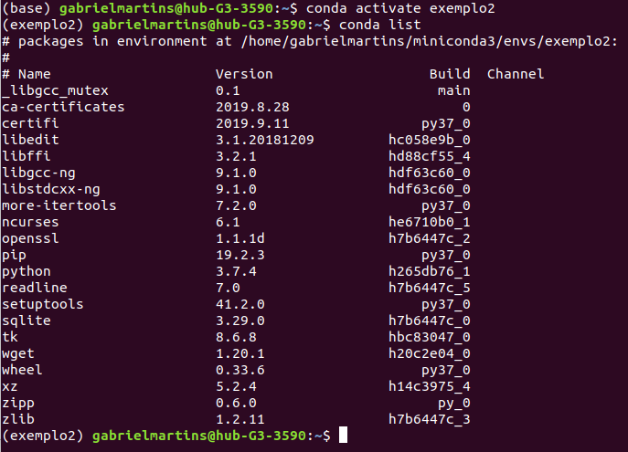

// lista de pacotes instalados no ambiente (exemplo3)

(base) gabrielmartins@hub-G3-3590:~$ conda activate exemplo3
(exemplo3) gabrielmartins@hub-G3-3590:~$ conda list
# packages in environment at /home/gabrielmartins/miniconda3/envs/exemplo3:
#
# Name Version Build Channel
_libgcc_mutex 0.1 main
ca-certificates 2019.8.28 0
certifi 2019.9.11 py37_0
libedit 3.1.20181209 hc058e9b_0
libffi 3.2.1 hd88cf55_4
libgcc-ng 9.1.0 hdf63c60_0
libstdcxx-ng 9.1.0 hdf63c60_0
ncurses 6.1 he6710b0_1
openssl 1.1.1d h7b6447c_2
pip 19.2.3 py37_0
python 3.7.4 h265db76_1
readline 7.0 h7b6447c_5
setuptools 41.2.0 py37_0
sqlite 3.29.0 h7b6447c_0
tk 8.6.8 hbc83047_0
wcwidth 0.1.7 py37_0
wheel 0.33.6 py37_0
xlwt 1.3.0 py37_0
xz 5.2.4 h14c3975_4
zlib 1.2.11 h7b6447c_3
(exemplo3) gabrielmartins@hub-G3-3590:~$

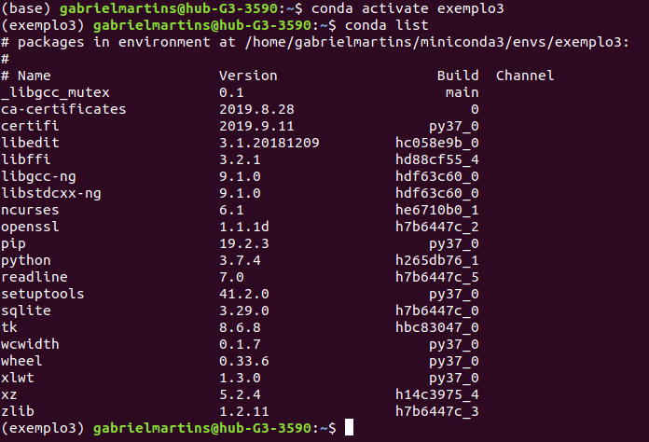

5- Apague um dos ambientes

(base) gabrielmartins@hub-G3-3590:~$ conda env remove -n exemplo1

Remove all packages in environment /home/gabrielmartins/miniconda3/envs/exemplo1:

(base) gabrielmartins@hub-G3-3590:~$

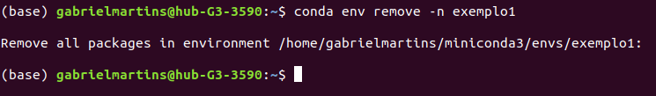

6 - O pacote Rstudio está presente no canal conda-forge?

(base) gabrielmartins@hub-G3-3590:~$ conda search rstudio --channel conda-forge
Loading channels: done
# Name Version Build Channel
rstudio 1.0.44 0 pkgs/r
rstudio 1.0.136 1 pkgs/r
rstudio 1.0.153 1 pkgs/r
rstudio 1.1.383 h2c9cdda_2 pkgs/r
rstudio 1.1.456 h6bb024c_1 pkgs/r
(base) gabrielmartins@hub-G3-3590:~$

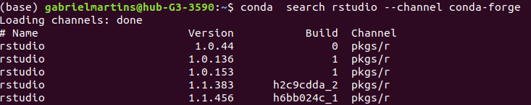
No canal conda-forge não foi encontrado o pacote rstudio.

7 - Quais as dependências instaladas após instalar o python?

Ao instalar o python alguns outros arquivos são necessários, eles são as dependências que devem ser instaladas em conjunto para o efetivo funcionamento do python.

(exercicio7) gabrielmartins@hub-G3-3590:~$ conda install python
Collecting package metadata (current_repodata.json): done
Solving environment: done

## Package Plan ##

environment location: /home/gabrielmartins/miniconda3/envs/exercicio7

added / updated specs:
- python

The following NEW packages will be INSTALLED:

_libgcc_mutex pkgs/main/linux-64::_libgcc_mutex-0.1-main
ca-certificates pkgs/main/linux-64::ca-certificates-2019.8.28-0
certifi pkgs/main/linux-64::certifi-2019.9.11-py37_0
libedit pkgs/main/linux-64::libedit-3.1.20181209-hc058e9b_0
libffi pkgs/main/linux-64::libffi-3.2.1-hd88cf55_4
libgcc-ng pkgs/main/linux-64::libgcc-ng-9.1.0-hdf63c60_0
libstdcxx-ng pkgs/main/linux-64::libstdcxx-ng-9.1.0-hdf63c60_0
ncurses pkgs/main/linux-64::ncurses-6.1-he6710b0_1
openssl pkgs/main/linux-64::openssl-1.1.1d-h7b6447c_2
pip pkgs/main/linux-64::pip-19.2.3-py37_0
python pkgs/main/linux-64::python-3.7.4-h265db76_1
readline pkgs/main/linux-64::readline-7.0-h7b6447c_5
setuptools pkgs/main/linux-64::setuptools-41.2.0-py37_0
sqlite pkgs/main/linux-64::sqlite-3.29.0-h7b6447c_0
tk pkgs/main/linux-64::tk-8.6.8-hbc83047_0
wheel pkgs/main/linux-64::wheel-0.33.6-py37_0
xz pkgs/main/linux-64::xz-5.2.4-h14c3975_4
zlib pkgs/main/linux-64::zlib-1.2.11-h7b6447c_3

Proceed ([y]/n)? y

Preparing transaction: done
Verifying transaction: done
Executing transaction: done
(exercicio7) gabrielmartins@hub-G3-3590:~$
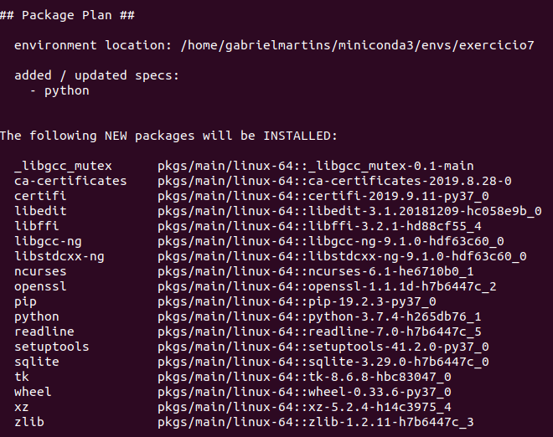
8 - Instale o pacote Pandas pelo pip

(exemplo2) gabrielmartins@hub-G3-3590:~$ pip install panda
Collecting panda
Downloading https://files.pythonhosted.org/packages/79/03/74996420528fe488ce17c42b6400531c8067d7eb661c304fa3aa8fdad17c/panda-0.3.1.tar.gz
Requirement already satisfied: setuptools in ./miniconda3/envs/exemplo2/lib/python3.7/site-packages (from panda) (41.2.0)
Collecting requests (from panda)
Downloading https://files.pythonhosted.org/packages/51/bd/23c926cd341ea6b7dd0b2a00aba99ae0f828be89d72b2190f27c11d4b7fb/requests-2.22.0-py2.py3-none-any.whl (57kB)
|████████████████████████████████| 61kB 1.5MB/s
Requirement already satisfied: certifi>=2017.4.17 in ./min(exemplo2) gabrielmartins@hub-G3-3590:~$ pip install panda
Collecting panda
Downloading https://files.pythonhosted.org/packages/79/03/74996420528fe488ce17c42b6400531c8067d7eb661c304fa3aa8fdad17c/panda-0.3.1.tar.gz
Requirement already satisfied: setuptools in ./miniconda3/envs/exemplo2/lib/python3.7/site-packages (from panda) (41.2.0)
Collecting requests (from panda)
Downloading https://files.pythonhosted.org/packages/51/bd/23c926cd341ea6b7dd0b2a00aba99ae0f828be89d72b2190f27c11d4b7fb/requests-2.22.0-py2.py3-none-any.whl (57kB)
|████████████████████████████████| 61kB 1.5MB/s
Requirement already satisfied: certifi>=2017.4.17 in ./miniconda3/envs/exemplo2/lib/python3.7/site-packages (from requests->panda) (2019.9.11)
Collecting urllib3!=1.25.0,!=1.25.1,<1.26,>=1.21.1 (from requests->panda)
Downloading https://files.pythonhosted.org/packages/e0/da/55f51ea951e1b7c63a579c09dd7db825bb730ec1fe9c0180fc77bfb31448/urllib3-1.25.6-py2.py3-none-any.whl (125kB)
|████████████████████████████████| 133kB 2.0MB/s
Collecting chardet<3.1.0,>=3.0.2 (from requests->panda)
Downloading https://files.pythonhosted.org/packages/bc/a9/01ffebfb562e4274b6487b4bb1ddec7ca55ec7510b22e4c51f14098443b8/chardet-3.0.4-py2.py3-none-any.whl (133kB)
|████████████████████████████████| 143kB 2.6MB/s
Collecting idna<2.9,>=2.5 (from requests->panda)
Downloading https://files.pythonhosted.org/packages/14/2c/cd551d81dbe15200be1cf41cd03869a46fe7226e7450af7a6545bfc474c9/idna-2.8-py2.py3-none-any.whl (58kB)
|████████████████████████████████| 61kB 3.4MB/s
Building wheels for collected packages: panda
Building wheel for panda (setup.py) ... done
Created wheel for panda: filename=panda-0.3.1-cp37-none-any.whl size=7259 sha256=c09679c2f6ef6d6236b50be6575ed7360e657b60fb2d1435566541b1e454e459
Stored in directory: /home/gabrielmartins/.cache/pip/wheels/c6/c8/45/06ed898b0bb401c1ff207dbb05b1587ff28860a236d98b1996
Successfully built panda
Installing collected packages: urllib3, chardet, idna, requests, panda
Successfully installed chardet-3.0.4 idna-2.8 panda-0.3.1 requests-2.22.0 urllib3-1.25.6
(exemplo2) gabrielmartins@hub-G3-3590:~$ iconda3/envs/exemplo2/lib/python3.7/site-packages (from requests->panda) (2019.9.11)
Collecting urllib3!=1.25.0,!=1.25.1,<1.26,>=1.21.1 (from requests->panda)
Downloading https://files.pythonhosted.org/packages/e0/da/55f51ea951e1b7c63a579c09dd7db825bb730ec1fe9c0180fc77bfb31448/urllib3-1.25.6-py2.py3-none-any.whl (125kB)
|████████████████████████████████| 133kB 2.0MB/s
Collecting chardet<3.1.0,>=3.0.2 (from requests->panda)
Downloading https://files.pythonhosted.org/packages/bc/a9/01ffebfb562e4274b6487b4bb1ddec7ca55ec7510b22e4c51f14098443b8/chardet-3.0.4-py2.py3-none-any.whl (133kB)
|████████████████████████████████| 143kB 2.6MB/s
Collecting idna<2.9,>=2.5 (from requests->panda)
Downloading https://files.pythonhosted.org/packages/14/2c/cd551d81dbe15200be1cf41cd03869a46fe7226e7450af7a6545bfc474c9/idna-2.8-py2.py3-none-any.whl (58kB)
|████████████████████████████████| 61kB 3.4MB/s
Building wheels for collected packages: panda
Building wheel for panda (setup.py) ... done
Created wheel for panda: filename=panda-0.3.1-cp37-none-any.whl size=7259 sha256=c09679c2f6ef6d6236b50be6575ed7360e657b60fb2d1435566541b1e454e459
Stored in directory: /home/gabrielmartins/.cache/pip/wheels/c6/c8/45/06ed898b0bb401c1ff207dbb05b1587ff28860a236d98b1996
Successfully built panda
Installing collected packages: urllib3, chardet, idna, requests, panda
Successfully installed chardet-3.0.4 idna-2.8 panda-0.3.1 requests-2.22.0 urllib3-1.25.6
(exemplo2) gabrielmartins@hub-G3-3590:~$

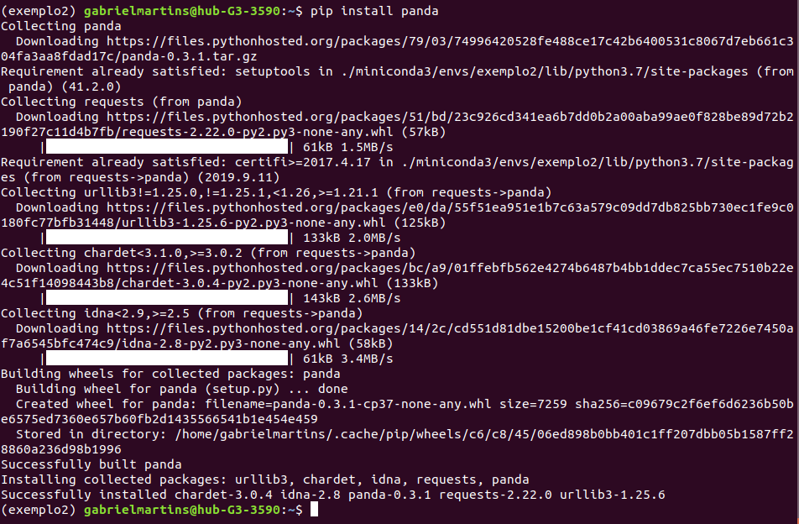

9 - Monte um ambiente conda novo com python versão 3 Execute o comando python para entrar no interpretador python A partir do interpretador execute o comando print "teste" Após terminar a execução execute ctrl+d para sair do interpretador Qual é o erro apresentado? O que deve ser feito para o print funcionar? Verifique se o mesmo comando apresenta erro no python 2

Ao utilizar o comando python é permitido o acesso ao interpretador python, o comando print “teste” apresenta um erro de sintaxe. A fim de resolver o problema deve ser utilizado o comando print (“teste”), conforme pode ser visto na imagem abaixo.
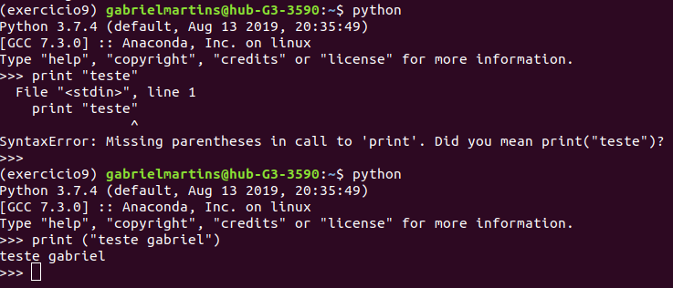

10 - Exporte um dos ambientes criados e passe por email para todos os alunos

name: exemplo2
channels:
- defaults
dependencies:
- _libgcc_mutex=0.1=main
- ca-certificates=2019.8.28=0
- certifi=2019.9.11=py37_0
- libedit=3.1.20181209=hc058e9b_0
- libffi=3.2.1=hd88cf55_4
- libgcc-ng=9.1.0=hdf63c60_0
- libstdcxx-ng=9.1.0=hdf63c60_0
- more-itertools=7.2.0=py37_0
- ncurses=6.1=he6710b0_1
- openssl=1.1.1d=h7b6447c_2
- pip=19.2.3=py37_0
- python=3.7.4=h265db76_1
- readline=7.0=h7b6447c_5
- setuptools=41.2.0=py37_0
- sqlite=3.29.0=h7b6447c_0
- tk=8.6.8=hbc83047_0
- wget=1.20.1=h20c2e04_0
- wheel=0.33.6=py37_0
- xz=5.2.4=h14c3975_4
- zipp=0.6.0=py_0
- zlib=1.2.11=h7b6447c_3
- pip:
- chardet==3.0.4
- idna==2.8
- panda==0.3.1
- requests==2.22.0
- urllib3==1.25.6
prefix: /home/gabrielmartins/miniconda3/envs/exemplo2

11- Escolha um dos ambientes enviados e monte no seu computador

(base) gabrielmartins@hub-G3-3590:~$ conda-env create -f newenv.yml

EnvironmentFileNotFound: '/home/gabrielmartins/newenv.yml' file not found

(base) gabrielmartins@hub-G3-3590:~$ conda-env create -f newenv.yml
Collecting package metadata (repodata.json): done
Solving environment: done

Downloading and Extracting Packages
certifi-2019.9.11 | 154 KB | ############################################################## | 100%
setuptools-41.2.0 | 662 KB | ############################################################## | 100%
pip-19.2.3 | 1.9 MB | ############################################################## | 100%
wheel-0.33.6 | 40 KB | ############################################################## | 100%
python-2.7.16 | 9.7 MB | ############################################################## | 100%
Preparing transaction: done
Verifying transaction: done
Executing transaction: done
#
# To activate this environment, use
#
# $ conda activate newenv
#
# To deactivate an active environment, use
#
# $ conda deactivate

(base) gabrielmartins@hub-G3-3590:~$

